

**Experiment 3**

**Student Name:** Sahil Kaundal **UID:** 21BCS8197

**Branch:** BE CSE (Lateral Entry) **Section/Group:** 616/A

**Semester:** 5th **Date of Performance:** 05/09/2022

**Subject Name:** DAA Lab **Subject Code:** 21-CSP-312

# Aim/Overview of the practical:

Code to find frequency of elements in a given array in O(n) time complexity.

# Task to be done/ Which logistics used:

To find the frequency of element in array using for loop.

1. **Algorithm/Flowchart:**

***Step 1:*** Let us make an array of size n taken by user.

***Step 2:*** Put the values in it.

***Step 3:*** Make a variable freq=1 and idx=1 and element=arr[0].

***Step 4:*** Now run a while loop to compare arr[idx-1] with arr[idx] if they are equal then increment of freq and ldx by 1 is there else print frequency of the element..

***Step 5:*** Run the while loop till idx<n.

# Steps for experiment/practical/Code:

#include <iostream>

using namespace std;

int main()

{

int n;

cout<<"Enter the length of array: "<<endl;

cin>>n;

int arr[n];

for(int i=0;i<n;i++)

{

cout<<"Enter the element of array: "<<endl;

cin>>arr[i];

}

int freq = 1;

int idx = 1;

int element = arr[0];

while (idx < n)

{

if (arr[idx - 1] == arr[idx])

{

freq++;

idx++;

}

else

{

cout << element << " Frequency of This Element is: " << freq << endl; element = arr[idx];

idx++;

freq = 1;

}

}

cout << element << " Frequency of This Element is: " << freq <<endl;

}

# Observations/Discussions/ Complexity Analysis:

Time complexity of finding frequency of elements of an array is O(n).

# Result/Output/Writing Summary:

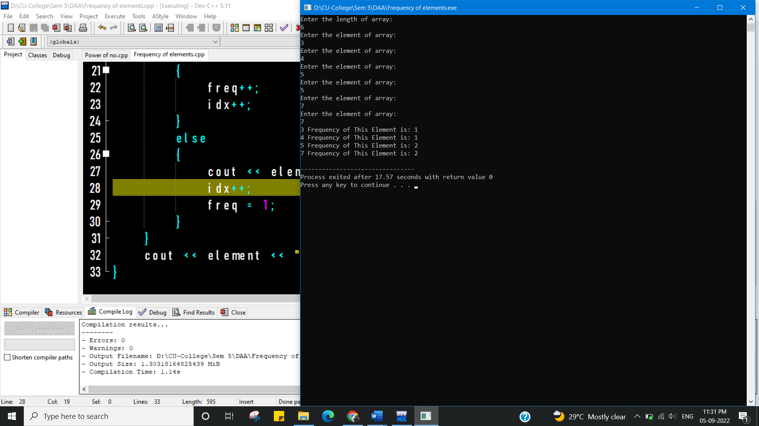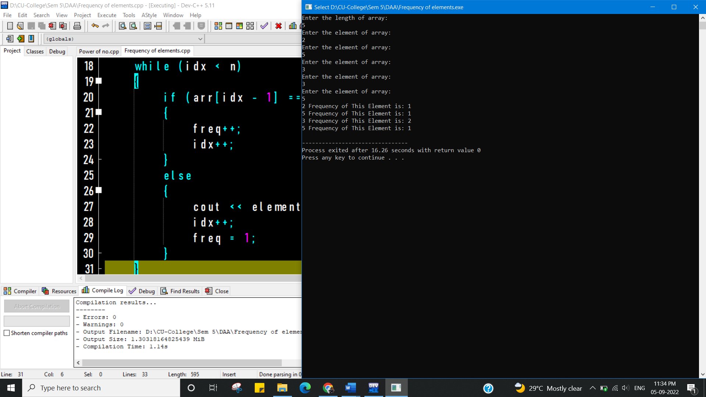

**Learning outcomes (What I have learnt):**

1. To learn how to calculate the frequency of the elements of an array.
2. To learn how to use for loop in these cases.

**Evaluation Grid (To be created as per the SOP and Assessment guidelines by the faculty):**

|  |  |  |  |
| --- | --- | --- | --- |
| Sr. No. | Parameters | Marks Obtained | Maximum Marks |
| 1. |  |  |  |
| 2. |  |  |  |
| 3. |  |  |  |
|  |  |  |  |